**31)**

**Aim:** To Design Push Down Automata using simulator to accept the input string anbn over input alphabets ∑ = {0, 1}.

**Diagram:**

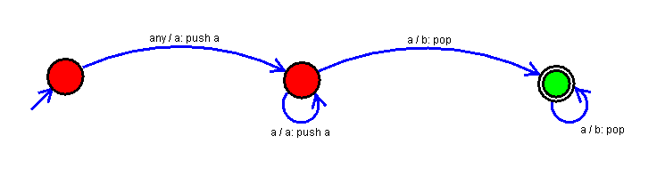

**Result:**

Thus, successfully executed Push Down Automata using simulator to accept the input string anbn over input alphabets ∑ = {0, 1}.